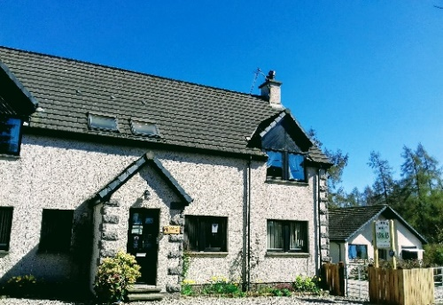
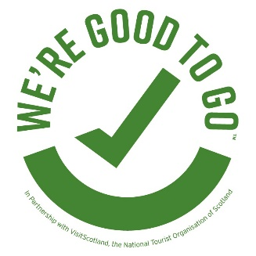
Larick House B&B
Newtonmore PH20 1AT
E larickhouse@newtonmore.biz
W www.newtonmoreaccommodation.com
T 01540 673762 M 07786 584864

Download Free Test & Protect Mobile Phone App: protect.scot

We are thrilled that, after the months of lockdown that we have all endured, you have decided to stay with us, visiting the Cairngorms National Park and Highlands. You will enjoy some of the most stunning scenery in the world, wide open spaces, an abundance of nature and the friendly community of Newtonmore.
Please note we only accept online or telephone bookings, not passing trade
Larick has worked tirelessly to develop a system to keep you, our guests, many who have become friends, and our staff, as safe as we possibly can. Inspiration drawn from the magnificent work done by all of those in the NHS, social caring professions, essential workers and our community. Following Scottish Government and HSE Guidelines we have a Risk Assessment and thorough Cleaning Checklist. Our COVID19 Protocol is derived on the information and working practices available from many different sector organisations who have painstakingly researched ‘best practice’ from hospitality and hygiene industries.

It is crucial to stay safe as individuals but to also protect others, to save lives. It is only through continued compliance that we will achieve the progress required to meet the criteria for the necessary, ever changing, restrictions.

Our Protocol will be constantly developing as new information and products become available, we will review and improve our approach in our evolving landscape. However, some new initiatives to reassure you are:
Housekeeping Similar to many other B&Bs and small hotels, this is our home as well as our business and we guarantee that our team maintains high standards of cleanliness. Covid19 has empowered us to revaluate our system and place new practices which will keep guests and us safe and healthy. We follow a new Covid19 Cleaning system, find a summary on our website for reassurance that this property is protected.
- Please always wear masks inside, except when in your bedroom or at table
- After breakfast, dining area cleared completely and directly placed in the dishwasher or item wiped and sanitised. Full cleaning done an hour after your departure
- Pillow and mattress protectors are sanitised or washed after every departure
- Daily housekeeping in your bedroom/en suite has been suspended. We will not enter you room during your stay. Please request replacement toilet roll if required
- All literature, leaflets, maps have been removed from your bedroom
- The information folder in your room is in a plastic folder which can be sanitised
Food Service A fully waitressed breakfast (ordered at Check In) will be served, at a chosen time, to maximise social distancing rules. Limited buffet style for cereals and fruit.
Personal Protective Equipment worn during service - aprons, gloves, masks and constant hand sanitising, wipe and sanitising surfaces/touchpoints.
Hygiene and Sanitising We use approved European Standard EN1276/14476 Hand Sanitiser Gel, Anti-Viral Carpet & Upholstery Sanitiser and C1 Cleaner Sanitiser effective against Covid19. To protect Guests and ourselves, PPE is paramount.
Bed Linen We want you to have a safe, comfortable, cosy night’s sleep. Bed linen and towels (used or not) will be stored in external store before being uplifted for the commercial laundry who store for 72hours before laundering. Pillow/mattress protectors and used blankets will also be stored before we launder them at over 60 ° with disinfectant/sanitiser detergent.
We have removed all:
- Cushions and breakfast chair cushions/pads
- Extra pillows – stored in wardrobe or ask if Room 1

Departure We ask, if you are able to help:
- leave your towels on the rail to dry
- open your windows to air the room
- to avoid heat wastage please turn radiators off
- tie up your rubbish bag

Delighted to hear your Comments, Opportunity for Improvements

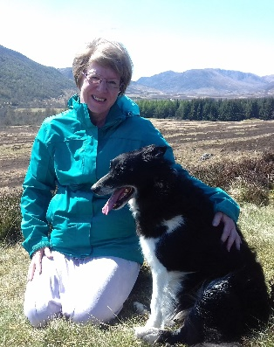
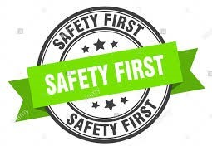

Covid19 Symptoms Policy

The safety and health of our guests and staff is crucial to us and everyone in our property should expect a sanitised, clean and comfortable stay. Please join us, in respecting Larick House B&B Covid19 Protocol, at all times.

Know the main symptoms of COVID19 and do not ignore them
Main Symptoms are:
- High Temperature: feel hot to touch on your chest or back
- New Continuous Cough: coughing a lot more than an hour, or 3 or more coughing episodes in 24hours (if you usually have a cough, worse than normal)
- Loss or Change to your Sense of Smell or Taste: you notice you cannot smell or taste anything, or things smell or taste different to normal

If aware of any symptoms above, please self-isolate to minimise
any risk of transmission, seek medical advice, request a test
and inform us (M 07786 584864)

Medical Advice: NHSinform.scot/test-and-protect or T 0800 028 2816

If following a test, you are confirmed to have COVID19 you must return home, if you reasonably can, using private transport but only driving yourselves, if you can safely. A refund will be issued for the rest of your stay. If not able to drive, your circumstances should be discussed with an appropriate health care professional.

In accordance with Test and Protect, people with symptoms are required to self-isolate for at least 7 days, and everyone in their household should isolate for 14 days. If the test is negative, everyone can end isolation. If the test is positive, everyone should continue to isolate, and the NHS Test and Protect Team will be in touch to start contact tracing. Those contacted through the Test and Protect programme will be required to self-isolate for at least 14 days.
If guests who are isolating can travel home safely,
avoiding the use of public transport, they should do this

If this is not possible, the guest should discuss this with the NHS Test and Protect team. National Assistance Helpline on 0800 111 4000. If you need help to isolate and cannot arrange it yourself have further discussion with the local Health Protection Team and local authority to ensure that you have suitable accommodation to isolate safely and effectively.

